**BrowserMonkey**



**User Manual**

v 1.0

**Software House One**

**Version History**

Document name: QA Team/scratch/User Manual.docx

Document version: 1.0

Document author: Adam McGinness 2009/06/05

Document author: Merrigan Baylis 2009/06/06

Document author: Paul Calcraft 2009/06/08

Document auditor: Ioanna Kyprianou 2009/06/08

Document auditor: Daniel Cooper 2009/06/08

Document auditor: Paul Calcraft 2009/06/08

Document auditor: Sohani Amiruzzaman 2009/06/08

**Table of Contents**

1 Installation 4

1.1 License 4

1.2 How to install 4

2 Introduction 5

3 Features 6

3.1 Search 6

3.2 Zoom 7

3.3 Images 9

3.4 Clickable links 9

3.5 Internet capability 9

3.6 Loading files 10

3.7 Google Search 11

3.8 Log File 12

3.9 Error Detection and Correction 13

# Installation

## License

Copyright (c) 2009, Software House One

All rights reserved.

Redistribution and use in source and binary forms, with or without

modification, are permitted provided that the following conditions are met:

* Redistributions of source code must retain the above copyright

notice, this list of conditions and the following disclaimer.

* Redistributions in binary form must reproduce the above copyright

notice, this list of conditions and the following disclaimer in the

documentation and/or other materials provided with the distribution.

* Neither the name of Software House One nor the

names of its contributors may be used to endorse or promote products

derived from this software without specific prior written permission.

THIS SOFTWARE IS PROVIDED BY Software House One ''AS IS'' AND ANY

EXPRESS OR IMPLIED WARRANTIES, INCLUDING, BUT NOT LIMITED TO, THE IMPLIED

WARRANTIES OF MERCHANTABILITY AND FITNESS FOR A PARTICULAR PURPOSE ARE

DISCLAIMED. IN NO EVENT SHALL Software House One BE LIABLE FOR ANY

DIRECT, INDIRECT, INCIDENTAL, SPECIAL, EXEMPLARY, OR CONSEQUENTIAL DAMAGES

(INCLUDING, BUT NOT LIMITED TO, PROCUREMENT OF SUBSTITUTE GOODS OR SERVICES;

LOSS OF USE, DATA, OR PROFITS; OR BUSINESS INTERRUPTION) HOWEVER CAUSED AND

ON ANY THEORY OF LIABILITY, WHETHER IN CONTRACT, STRICT LIABILITY, OR TORT

(INCLUDING NEGLIGENCE OR OTHERWISE) ARISING IN ANY WAY OUT OF THE USE OF THIS

SOFTWARE, EVEN IF ADVISED OF THE POSSIBILITY OF SUCH DAMAGE.

## How to install

Extract the contents of the zip installation package. To run, execute BrowserMonkey.jar.

Version 6 of the Java Runtime Environment is required, which can be obtained from here:

<http://java.sun.com/javase/downloads/index.jsp>

# Introduction

BrowserMonkey is an HTML browser designed for opening HTML 4.1 compliant files with a subset of HTML rendering functionality, defined by the user requirements.

BrowserMonkey has a plethora of features that allow the user to experience the features of a high end browser in a lightweight package. It was designed to be used in tractors by agricultural workers. As such, the interface and list of features BrowserMonkey encompasses have been carefully selected to maximize usability and efficiency.

BrowserMonkey allows the user to access the *internet*, *zoom* on text, click *links* and *search* the page of an item.

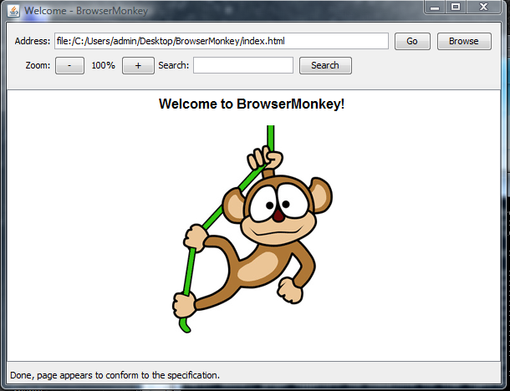

# Features

## Search

BrowserMonkey features a search system that can be activated by clicking the search bar and typing the information that needs to be searched. This allows you to find a specific item within a document. Once the *Search* button is pressed, the matches to the search term will be highlighted in green, with the status of the amount of matches found at the bottom of the page.

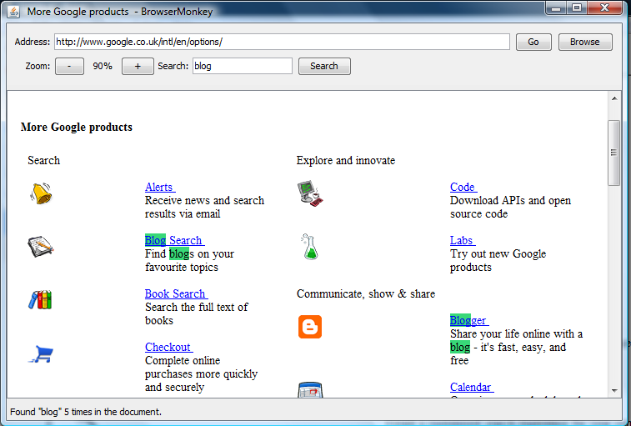

However if nothing is found a *status update* at the bottom of the screen will signify the current state of the browser.

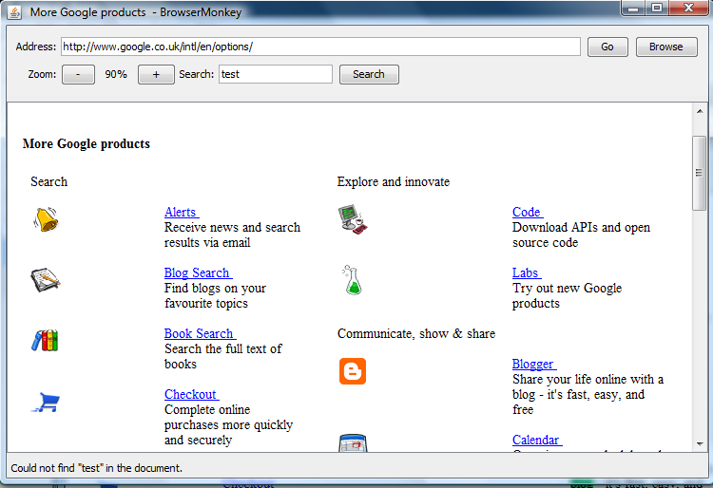

## Zoom

The browser features a zooming system activated by the user by pressing either the positive or negative icons. The zoom levels available (as percentages) are: 50, 60, 70, 80, 90, 100, 125, 150, 175, 200, 250, and 300. This allows the user to see more items on the page by zooming out or see the page in more detail by zooming in.

The following shows the zoom in action:

Zoomed in to 300%

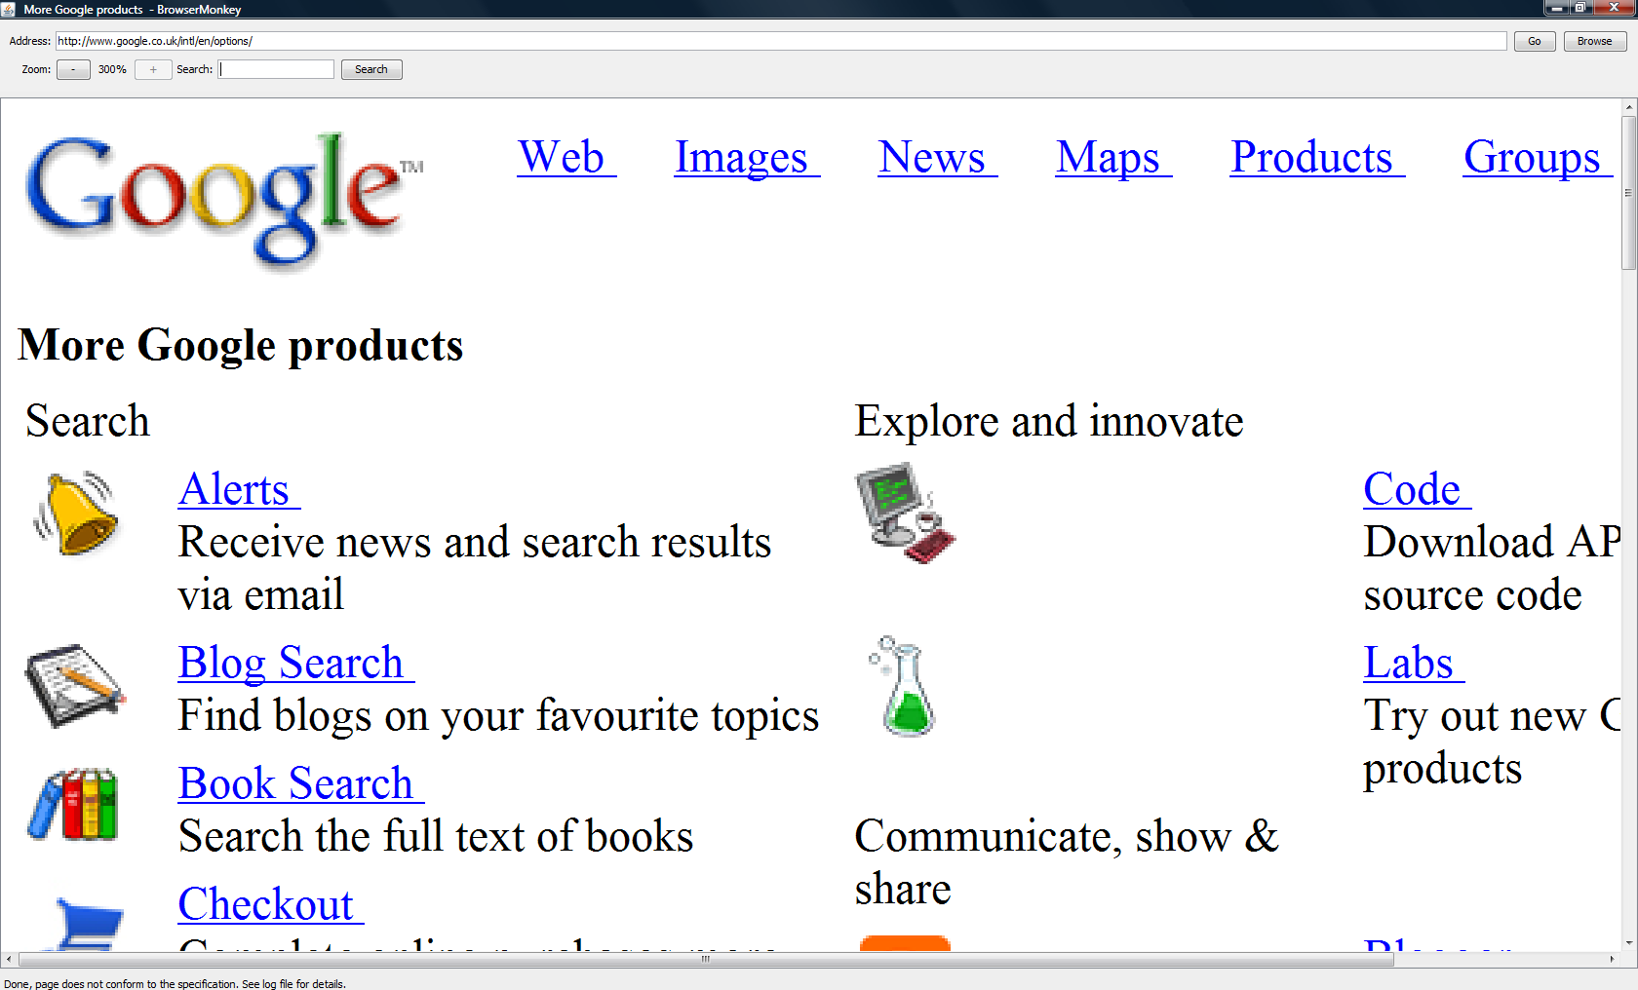

Zoomed out to 50%

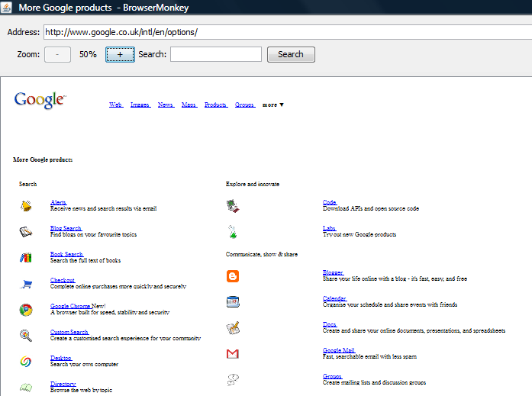

## Images

Images can also be displayed in our Browser, this allows the engineers to use diagrams in their manual pages, and allows more full viewing of the web.

## Clickable links

Some words and phrases in the documentation allow the user to move from one page to another. If a phrase is highlighted blue with an underline, you can click the link and move to a new page.

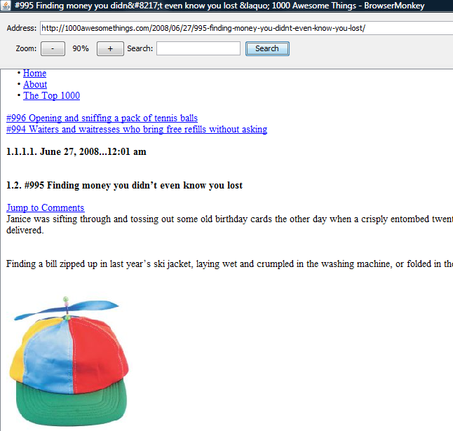

## Internet capability

In order to access the internet simply enter a URL into the *Address* bar, the browser will take it from there provided you have a working internet connection. Once on the website mentioned, you can again, click links to navigate through the website.

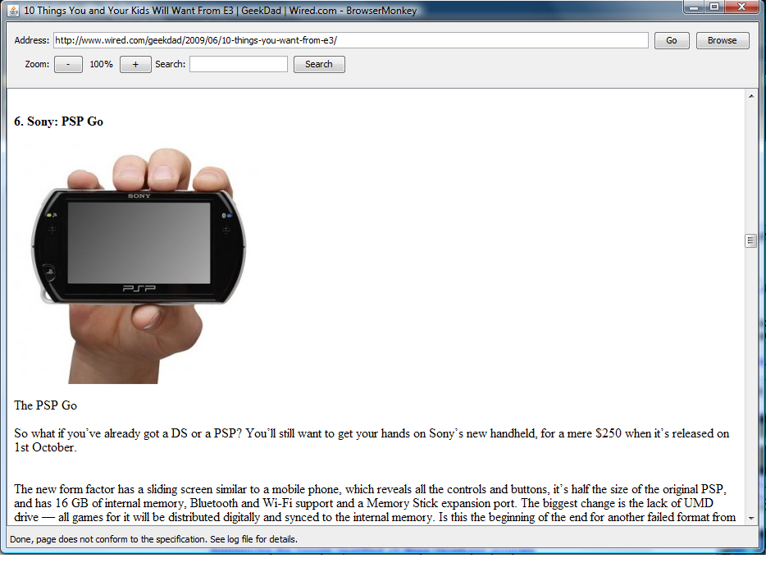

## Loading files

If you wish to access any saved HTML WebPages, simply click on the *Browse* button. This will then bring up a file locator for ease of use.

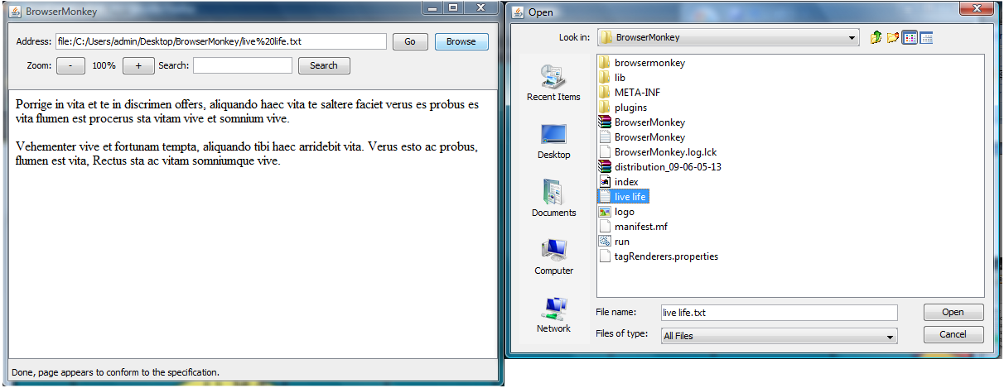

Alternatively it is possible to load files by just typing in the full address of the location into the *address* bar. For example:

*file:/C:/Users/admin/Desktop/BrowserMonkey/live%20life.txt*

or

*C:\Users\admin\Desktop\BrowserMonkey\live life.txt* (like a standard path)

Loading from the *command line* is also possible, by typing *java -jar BrowserMonkey.jar "specificStartPage.html"* defining the start page for the browser.

## Google Search

If you need to search for something using Google, you can simply input queries from BrowserMonkey's address bar. Just type in “*g search term*” and BrowserMonkey will automatically search your query in Google (mobile) for you. This allows web searches even though web forms aren’t supported.

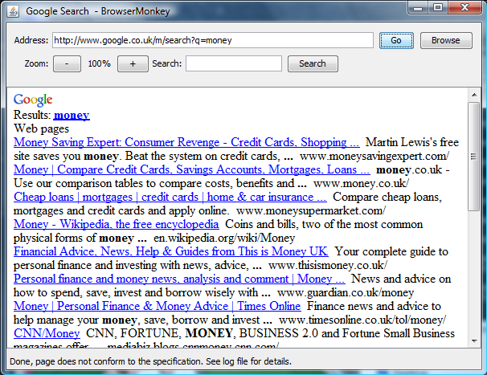

## Log File

The log file stores any errors identified with the currently used HTML document. This allows engineers to see any incorrect code and correct it if they wish.

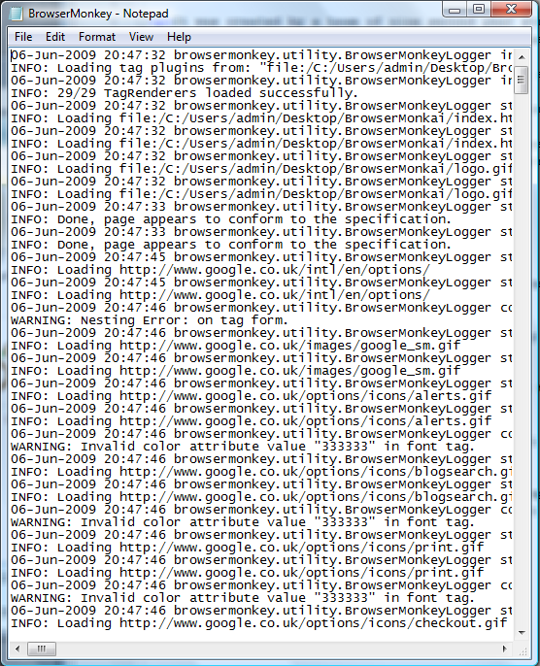

## Error Detection and Correction

The error detection identifies where tags have not been closed properly, amongst other HTML conformance errors. These problems are taken down in the form of a log file, allowing the engineer to make changes to their code to better suit the browser. However, the browser corrects many of these mistakes before rendering, so it is flexible to inconsistencies with the HTML specification.